Dependent variables: Wing length, Adult mass, Pupae mass

Independent variables: Emergence Date, Original densities, Per capita mortality, Predator Density, DOC, Pond Temp

|  |  |  |  |  |  |  |  |  |  |  |  |  |
| --- | --- | --- | --- | --- | --- | --- | --- | --- | --- | --- | --- | --- |
|  | **Site** | **Year** | **SampDate1** | **EmerDate** | **LnImmatureslitersampdate1** | **percapitamort** | **lnBeetleliter** | **DOCmean** | **Temp** | **Pupaemass** | **Winglength** | **AdultMass** |
| 1 | Black | 2011 | 5/24/2011 | 6/16/2011 | 3.518024 | 0.103642 | 0.156764 |  | 9.182805 | 1.491217 | X |  |
| 2 | Black | 2012 | 5/8/2012 | 5/28/2012 | 2.98366 | 0.102479 | 0.073361 |  | 8.131086 | X | X |  |
| 3 | Dispersal pond | 2017 | 6/1/2017 |  | 2.63135 |  |  |  |  |  |  |  |
| 4 | East | 2011 | 5/24/2011 | 6/14/2011 | 2.618207 | 0.092285 | 0.122652 |  | 8.692377 | 1.200521 | X |  |
| 5 | East | 2012 | 5/8/2012 | 6/2/2012 | 0.749224 | 0.009937 | 0.031379 |  | 5.744982 | X | X |  |
| 6 | East | 2017 | 5/17/2017 | 6/11/2017 | 1.960963 | 0.048679 | 0.093709 | 44.25222 |  | 1.007917 | 9.216667 | 0.626667 |
| 7 | Experiment | 2017 |  | 6/10/2017 |  |  |  | 43.12333 | 7.993333 |  |  |  |
| 8 | Ice | 2011 | 5/24/2011 | 6/14/2011 | 0.747813 | 0.021315 | 0.391959 |  | 7.796733 | X | X |  |
| 9 | Ice | 2012 | 5/8/2012 | 6/4/2012 | 0.226038 | 0.006741 | 0.268979 |  | 8.330678 | X | X |  |
| 10 | Ice | 2017 | 5/17/2017 | 6/7/2017 | 1.305336 | 0.056401 | 0.380261 | 26.32833 | 9.302733 | 1.64125 | 10.70417 | 1.7 |
| 11 | JuncusTown | 2017 | 5/19/2017 | 5/28/2017 | 0.852295 | 0.027673 | 0 | 23.37333 |  | 0.93625 | 8.925 | 0.692083 |
| 12 | Mozvalley | 2017 | 5/23/2017 | 6/6/2017 | 3.090713 | 0.07288 | 0.159655 | 46.01833 |  | 1.097857 | 9.770833 |  |
| 13 | NoOil | 2017 | 5/19/2017 | 5/29/2017 | 2.811124 | 0.017147 | 0.135381 | 45.39667 |  |  | 8.625 |  |
| 14 | Oil | 2017 | 5/17/2017 | 5/30/2017 | 1.706055 | 0.038097 | 0.038403 | 38.69167 | 9.668328 | 1.373913 | 10.14167 |  |
| 15 | SBS | 2017 | 5/17/2017 | 6/3/2017 | 2.770484 | 0.209931 | 0.089347 | 24.73667 |  | 1.2076 | 9.741667 | 0.867083 |
| 16 | SeahorseWetland | 2017 | 5/23/2017 | 6/10/2017 | 1.082251 | -0.01185 | 0.191103 | 24.79 |  | 1.0424 | 9.7875 | 0.8275 |
| 17 | ShotgunFairy | 2017 | 5/17/2017 | 6/1/2017 | 0.842335 | 0.039348 | 0.030132 | 57.89556 |  |  |  |  |
| 18 | Target | 2017 | 5/17/2017 | 6/5/2017 | 1.22422 |  |  | 48.79667 |  | 1.577857 | 10.32917 |  |
| 19 | Vulgaris | 2011 | 5/24/2011 | 6/12/2011 | 2.998785 | 0.051029 | 0.354727 |  | 7.849901 |  |  |  |
| 20 | Vulgaris | 2012 | 5/8/2012 | 5/23/2012 | 2.629268 | 0.094259 | 0.147094 |  | 6.308046 |  |  |  |
| 21 | Vulgaris | 2017 | 5/17/2017 | 6/3/2017 | 2.907141 | 0.029061 | 0.214142 | 75.15 | 8.743286 | 1.084 | 9.491667 |  |
| 22 | Vulgaris road | 2017 | 5/20/2017 | 6/5/2017 | 2.390471 | 0.001207 | 0.295648 | 59.365 |  |  | 9.6625 | 0.971667 |
| 23 | Vulgaris small | 2017 | 5/20/2017 | 6/7/2017 | 1.659185 | 0.055534 | 0.167665 | 45.02833 |  |  | 10.12917 |  |
| 24 | Waterfall | 2017 | 6/4/2017 |  | 2.186229 |  |  |  |  |  |  |  |

Wing length and Adult mass exponential (**Each points is an individual from different ponds, Don’t know if relationship varies by pond)

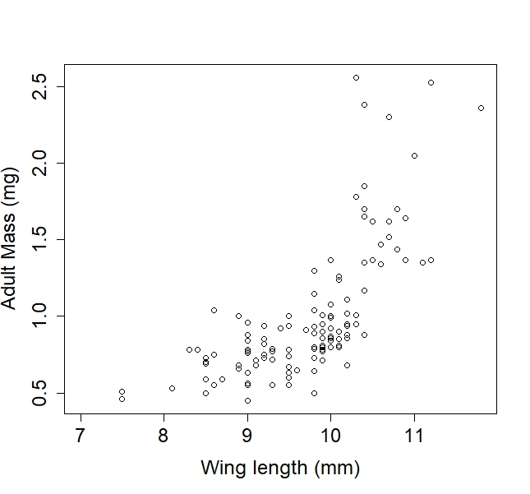

Averages by ponds

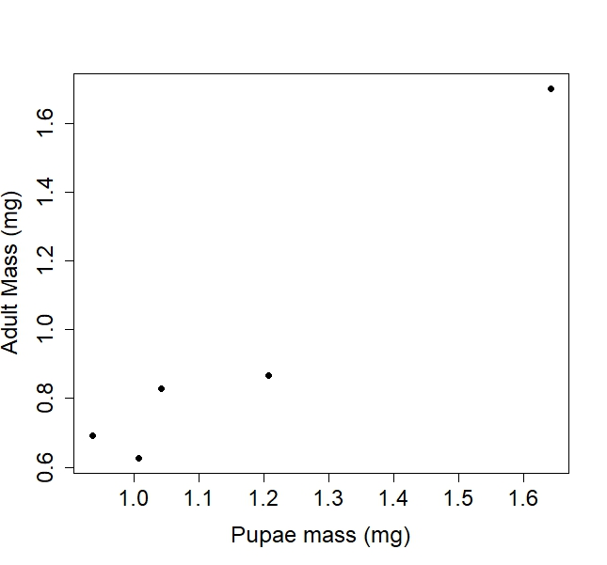 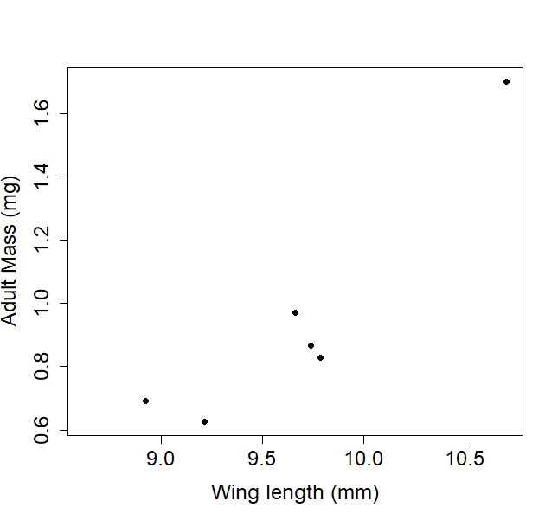

Average larval and pupal densities w/ SE from ponds. The last date is the last sampling date BEFORE moz started emerging. (**some issues w. dates)

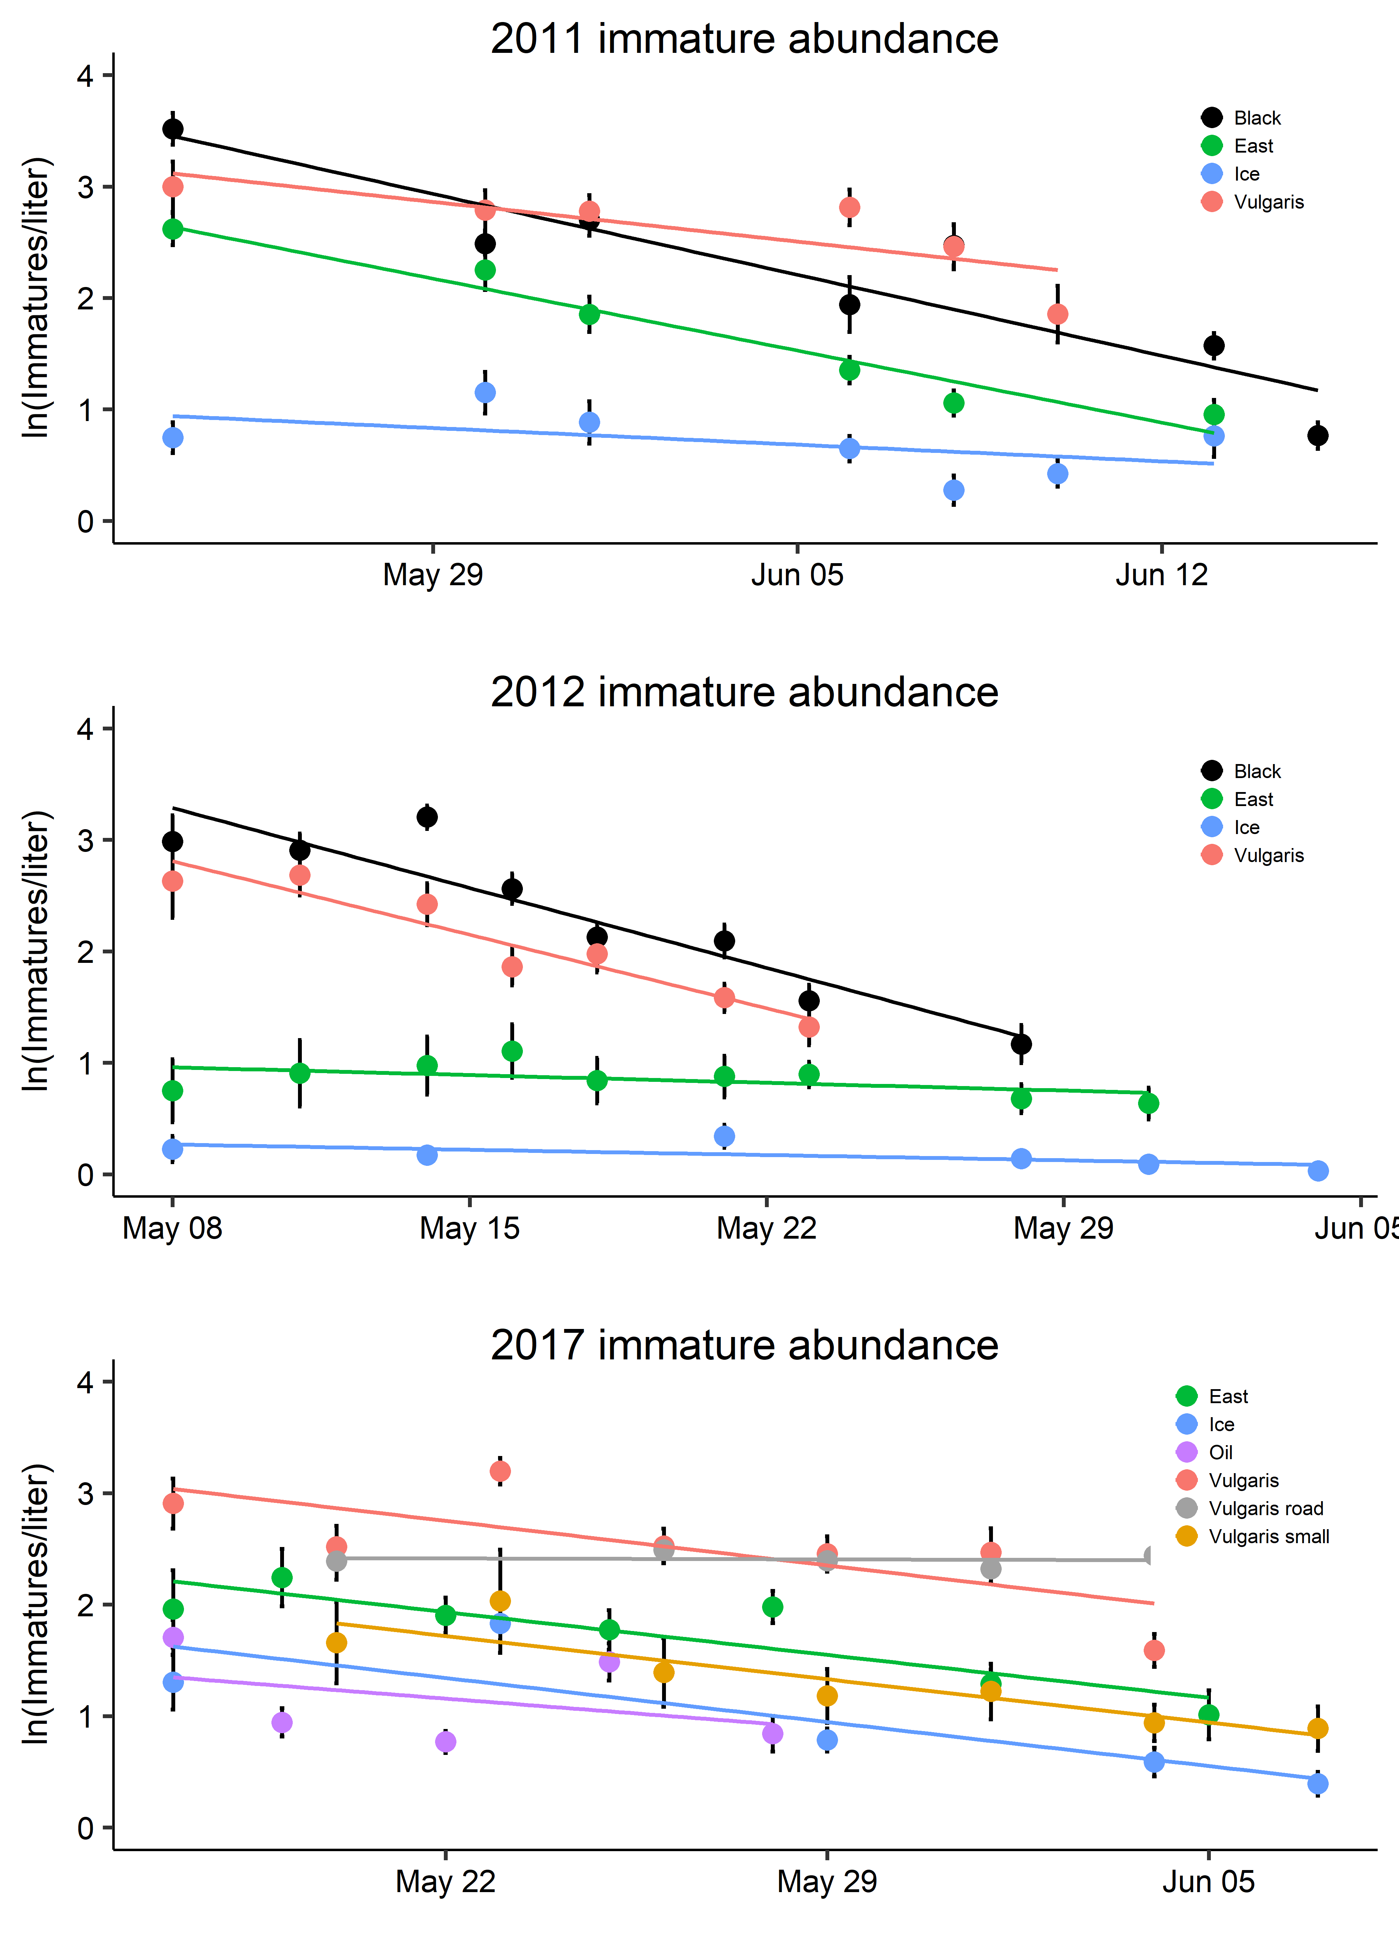

Each point is a pond from 2011, 2012 or 2017. Per capita mortality calculated as -1*slope of line in 1st figure. Plotted against the initial density/liter (from first sampling event of year). Positive slope (significant) indicates that there is density dependent mortality.

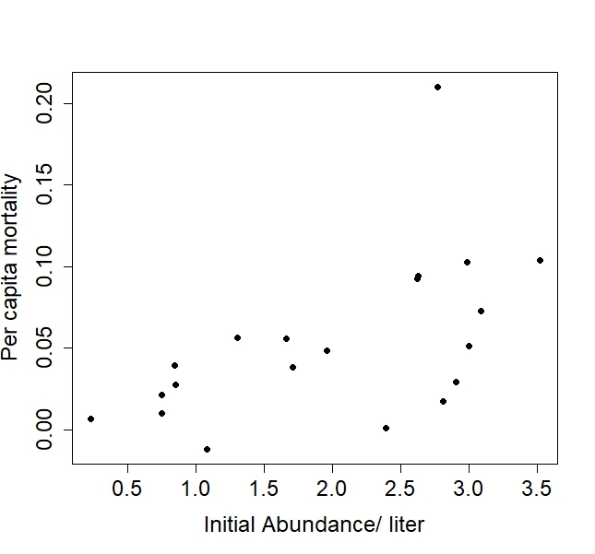

Call:

lm(formula = (slope * -1) ~ Larvaepupaeliter, data = pondsallyearssummary)

Residuals:

Min 1Q Median 3Q Max

-0.065139 -0.014156 0.003504 0.018606 0.132357

Coefficients:

Estimate Std. Error t value Pr(>|t|)

(Intercept) -0.004285 0.020011 -0.214 0.83272

Larvaepupaeliter 0.029547 0.009186 3.216 0.00454 **

---

Signif. codes: 0 ‘***’ 0.001 ‘**’ 0.01 ‘*’ 0.05 ‘.’ 0.1 ‘ ’ 1

Residual standard error: 0.04067 on 19 degrees of freedom

Multiple R-squared: 0.3525, Adjusted R-squared: 0.3185

F-statistic: 10.35 on 1 and 19 DF, p-value: 0.004543

Pond Temps Across 3 years – very comparable

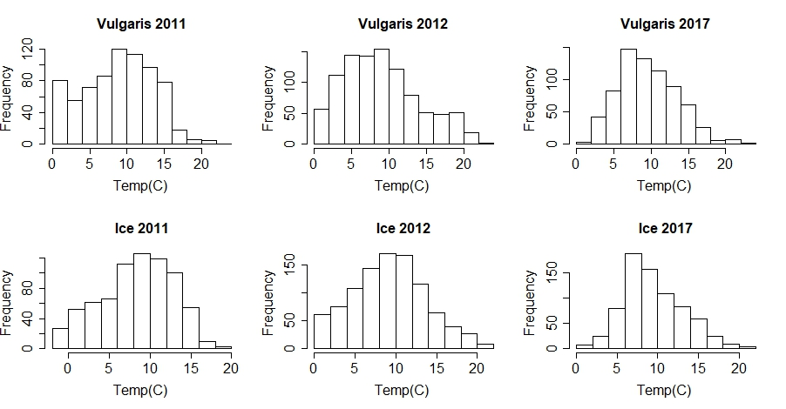

Average pond temps during immature development

Site Year N Temp sd se ci

1 Experiment 2017 448 7.993333 4.743873 0.2241269 0.4404733

2 Ice 2011 551 7.796733 4.571499 0.1947524 0.3825496

3 Ice 2012 678 8.330678 4.770590 0.1832134 0.3597348

4 Ice 2017 509 9.302733 3.942900 0.1747660 0.3433531

5 Oil 2017 299 9.668328 3.702942 0.2141467 0.4214314

6 Vulgaris 2011 503 7.849901 4.867859 0.2170471 0.4264326

7 Vulgaris 2012 174 6.308046 4.330273 0.3282771 0.6479440

8 Vulgaris 2017 413 8.743286 4.211573 0.2072380 0.4073757

9 VulgarisRoad 2017 437 7.789412 3.538727 0.1692802 0.3327068

10 Black 2011 599 9.182805 4.516087 0.1845223 0.3623905

11 Black 2012 534 8.131086 3.644324 0.1577053 0.3098002

12 East 2011 551 8.692377 4.428751 0.1886711 0.3706041

13 East 2012 558 5.744982 3.800104 0.1608712 0.3159884

Beetle densities average over the time of immature development. Beetle densities don’t seem to affect per capita mortality.

Adult Wing length not related to pond DOC

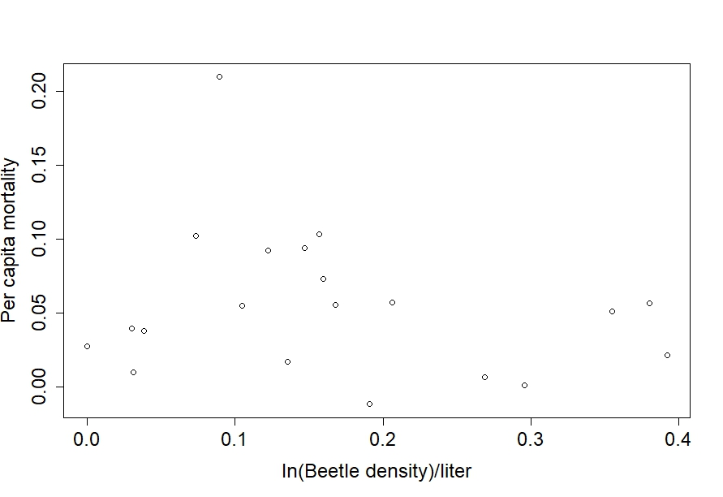 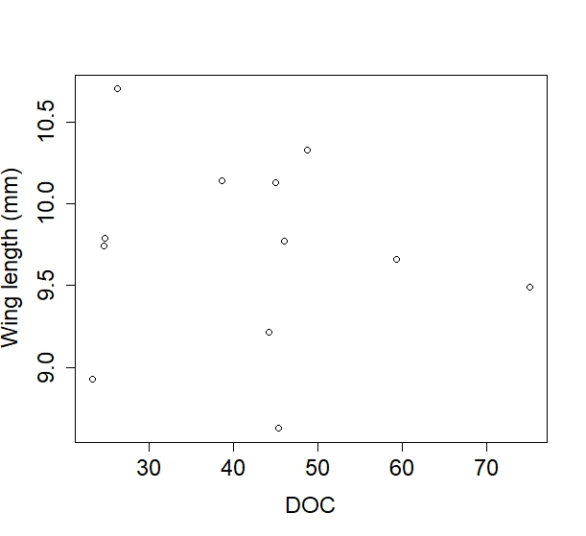

Surprisingly, MORE per capita mortality = larger mosquitoes! (The 0.2 from SBS could be an outlier or an error in data…go back and investigate)

